# Excel Test

**Time of the Test**: 30 Minutes, counted from the sending of the mail with the files. The end time of the test will be the one in which the fully completed Excel file is received. If the file is not received before 30 minutes, a grade of 0 will be assigned to the test.

The objective of this test is to validate the knowledge that each candidate has of the selection process in Excel, which consists of 5 points to perform which have the same value. It is important to clarify that none of the points is a requirement to perform another.

**Description of the table in the Excel file:**

The attached file contains a customer database where each line presents information for a single customer (no other contains information for the same customer). In this it is possible to find information such as the name of the establishment, the municipality to which each client belongs, the number of boxes they buy, among others.

Additionally, the file contains 4 tabs, where each of these is destined to carry out a specific exercise and on which each point made will be scored.

**Exercises to perform:**

The "BDD TOTAL" tab contains the information required for other exercises.

1. At this point it is necessary to organize a new database in the "BDD REQUERIDA" tab which must exactly match the following fields (not to be missed or left over any field):
   1. PROPIETARIO
   2. NOMBRE DEL ESTABLECIMIENTO
   3. BARRIO
   4. MUNICIPIO
   5. CIUDAD (This information is obtained in column B)
   6. CAJAS COMPRADAS
   7. Cajas / Pedido
   8. CENTRO (This information is obtained in column B)
2. In the tab "LISTA GUAPOTA" it is required to create a list only with clients that belong to the municipality of GUAPOTA; This must be organized from the customer who buys the most boxes to the one who has the least purchase.
3. This point does not have a specific tab, you must create a new tab and define the name you like. In this you must find a table identical to the following and completely filled out.

The objective of the table is to know how many boxes and customers are related to each of the municipalities listed below and also to know how much the average number of boxes per order is.

|  |  |  |  |
| --- | --- | --- | --- |
| **MUNICIPIO** | **CAJAS COMPRADAS** | **TOTAL CLIENTES** | **Cajas / Cliente** |
| ARATOCA |  |  |  |
| BARBOSA |  |  |  |
| BARICHARA |  |  |  |
| BARRANCABERMEJA |  |  |  |
| CONFINES |  |  |  |
| COROMORO |  |  |  |
| GUAPOTA |  |  |  |
| Total general |  |  |  |

1. In the tab "COMPLETAR TABLA" there is a list of 31 clients. For this point it is necessary to complete the fields:
   1. NOMBRE DEL ESTABLECIMIENTO
   2. BARRIO
   3. Cajas / Pedido
2. 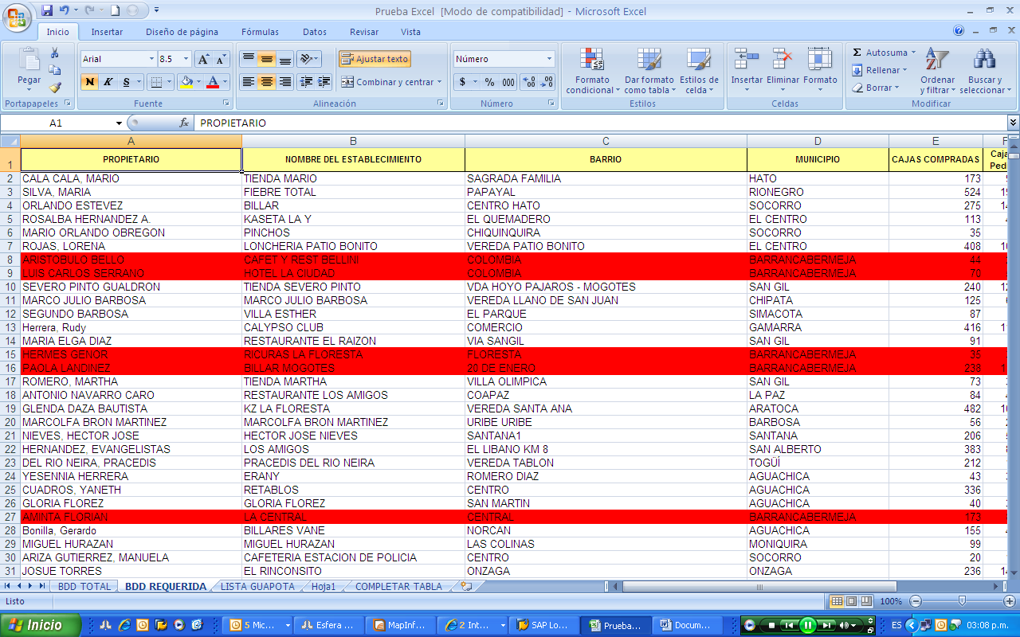This last point can be made in the "BDD TOTAL" tab or in the "BDD REQUERIDA" tab (preferably in the 2nd one) and to complete it, it is necessary to highlight in red all the lines that belong to the municipality " BARRANCABERMEJA ”, as shown below: